**Project Description:**

StyLEst is a cutting-edge app designed to provide a seamless and stylish online shopping experience, focusing on fashion and beauty products. Combining "Style" with "LEst" (implying "Lifestyle & Elegance" or "Best"), StyLEst aims to offer users a curated selection of elegant products, comprehensive details, and personalized recommendations. The app is user-friendly, allowing anyone to easily create an account, browse through a diverse range of items, and make purchases with a simple checkout process. Additionally, StyLEst fosters a vibrant community for fashion inspiration, making it the go-to platform for anyone looking to enhance their style and elegance effortlessly.

**Requirements Summary:**

| **MINIMUM REQUIREMENTS** | Processor Cores | Dual Core |
| --- | --- | --- |
| OS | Android 7.0, iOs 11.0 |
| RAM | 2 GB |
| **RECOMMENDED REQUIREMENTS** | Processor Cores | Quad Core or Higher |
| OS | Android 9.0 (Pie), iOs 14.0 |
| RAM | 4 GB or higher |
| **OTHER REQUIREMENTS** | Permissions | Notifications, Storage, Location and Camera |

Table 1. System Requirements

These specifications guarantee that the application will function flawlessly on a range of hardware configurations and offer all the functionality needed for a shopping experience while respecting security and user privacy policies.

# Overview

StyLEst is an advanced smartphone application that redefines the internet shopping experience, emphasizing cosmetic and fashion items. It promises consumers a carefully chosen assortment of high-end products, in-depth product insights, and tailored suggestions by fusing "Style" and "LEst" to represent a fusion of elegance and lifestyle. StyLEst's user-friendly layout makes it easy for consumers to register, browse a wide selection of products, and finish transactions.

| **Technique** | **Description** |
| --- | --- |
| Usability Specifications | Clear and quantifiable standards for assessing StyLEst's usability are outlined in the usability guidelines. These standards cover features like responsive design, easy checkout, clear product descriptions, effective search, intuitive navigation, and seamless social interaction. |
| Heuristics Evaluation | To find and fix usability flaws, experts assess StyLEst against accepted usability concepts such as user control, consistency, mistake prevention, adaptability, aesthetically pleasing design, and visibility of system state. |
| Participant Survey and Feedback | In order to determine preferences, evaluate user happiness, and pinpoint areas in need of development, StyLEst uses surveys and usability testing to get input from users. This ensures that the app fulfills user requirements and improves the overall shopping experience. |

Three components comprise the tasks for the StyLEst app prototype evaluation: Main Navigation Tasks, Product Browsing Tasks, and Checkout Tasks. The following are some tasks that participants will complete to show off the functioning of the prototype:

* Utilize the main menu to navigate between the app's various parts.
* To find particular products, look through the product categories and filter choices.
* Put things in your shopping basket and check out.
* Change how many things are in the trolley.
* When checking out, provide your payment and shipping details.

These tasks were chosen to evaluate how easy it was to navigate, how well it worked for browsing and product selection, and how well it worked for completing purchases on the prototype. In order to give users a smooth and pleasurable shopping experience, several precautions were taken into consideration when designing the prototype.

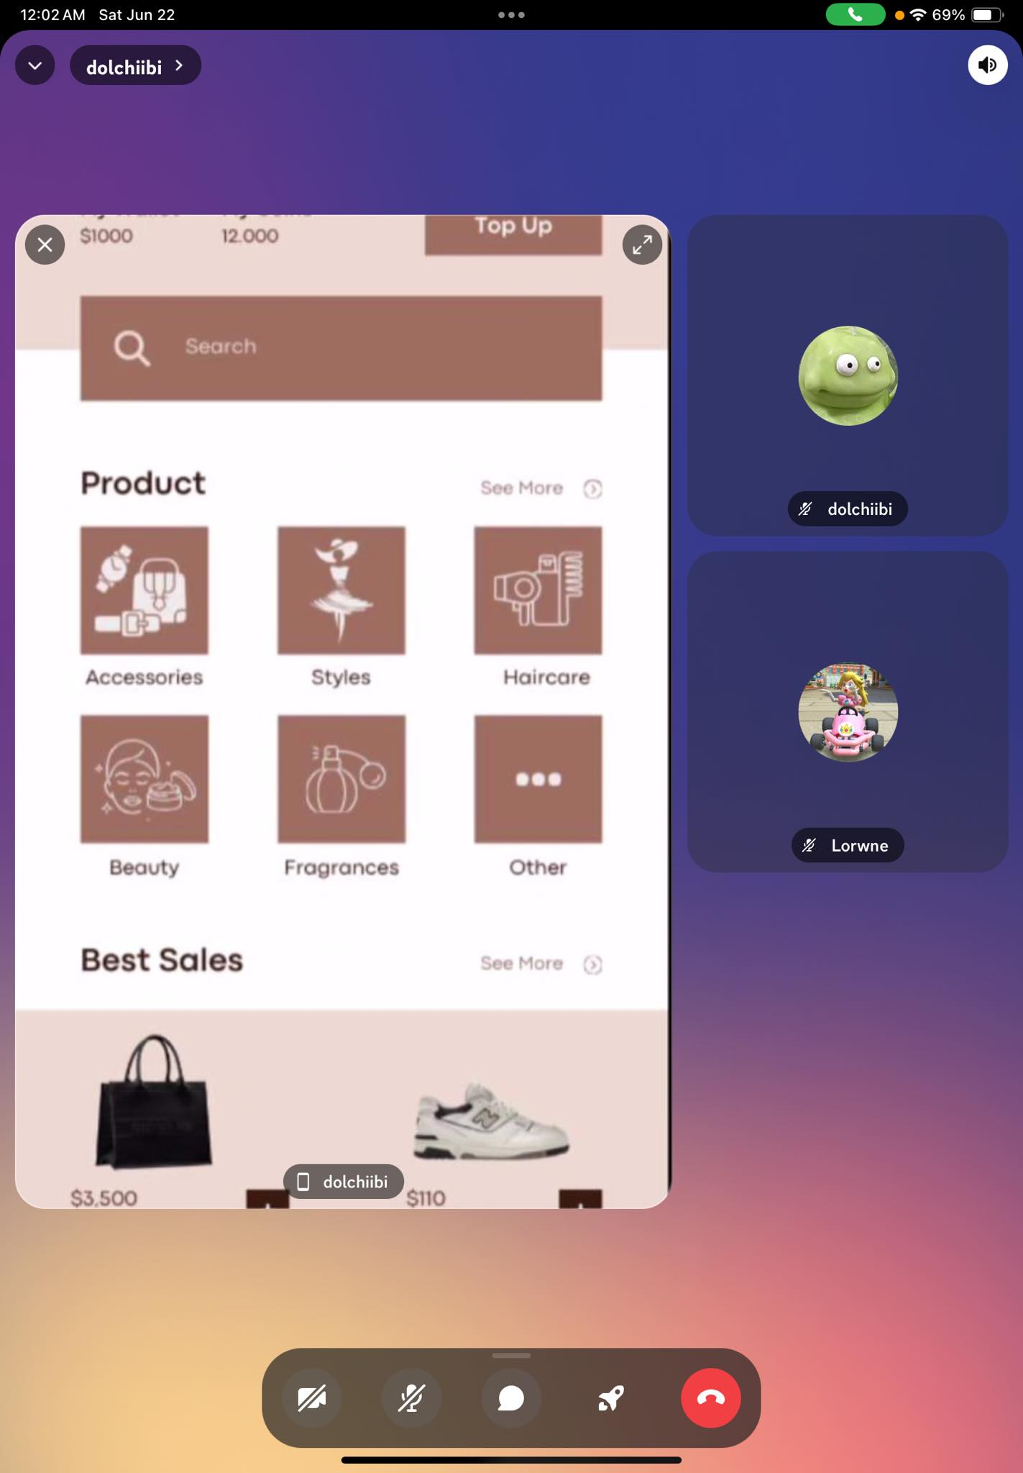

**Discord Call**

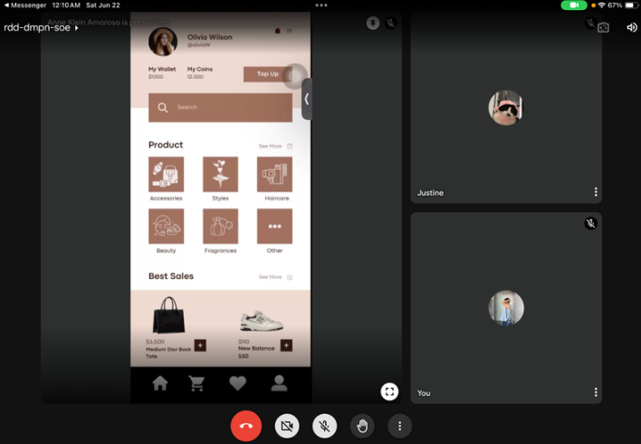

**Google Meet**

# Data Presentation

**Data Analysis**

## Usability Specifications

During the online testing with the participants, Team ABA has noticed that the participants interacted exceptionally well with the STYLESt shopping app. Almost all the participants were able to finish each task, which included the Main Menu task, Shopping Cart, and Checkout, with little to no issues. Participants found the app easy to use, primarily because it adopted familiar elements from other shopping applications. They quickly learned and memorized the steps and navigation, easily maneuvering through the app.

| Task | Mean | Interpretation | Classification |
| --- | --- | --- | --- |
| Main Menu Task | 0.45 minutes | Highly Acceptable | Successful |
| Shopping Cart | 1 minute and 30 seconds | Highly Acceptable | Successful |
| Checkout | 2 minutes and 45 seconds | Highly Acceptable | Successful |

Table 3. Task Time

Table 3 shows the results of the timed tasks during the online testing. The data shows that the participants were overall able to accomplish each task section with amazing times. With this result, the prototype is interpreted as successful in all three (3) task sections.

The Main Menu task was completed in an average of 0.45 minutes, which is classified as "Highly Acceptable" and indicates a successful outcome. The Shopping Cart task was completed in an average of 1 minute and 30 seconds, also classified as "Highly Acceptable" and deemed successful. Lastly, the Checkout task was completed in an average of 2 minutes and 45 seconds, maintaining the "Highly Acceptable" classification and a successful interpretation.

## Heuristic Evaluation

The StyLESt prototype will be evaluated within each type of Heuristic Evaluation.

1. Visibility of System Status:

StyLESt provides clear and immediate feedback on user actions, ensuring users are aware of what is happening at any moment. Loading indicators and confirmation messages are prominently displayed, keeping users informed and reducing uncertainty.

2. Match Between System and the Real World:

The application uses familiar terminology and icons consistent with standard shopping applications. This alignment with real-world concepts makes it easy for users to understand and navigate the app.

3. User Control and Freedom:

StyLESt offers easily accessible undo and redo functions, allowing users to correct mistakes effortlessly. Navigation options such as back buttons and clearly marked exits prevent users from feeling trapped within any section of the app.

4. Consistency and Standards:

The design of StyLESt adheres to established conventions found in popular shopping apps. Icons, buttons, and navigation menus are consistent throughout the app, ensuring users do not need to wonder whether different words, situations, or actions mean the same thing.

5. Error Prevention:

StyLESt incorporates preventive measures to avoid errors. For instance, form fields are validated in real-time, and users are prompted to confirm critical actions like purchases or deletions, minimizing the likelihood of mistakes.

6. Recognition Rather Than Recall:

The app is designed to minimize the user's memory load by making objects, actions, and options visible. Users do not need to remember information from one part of the interface to another, enhancing ease of use.

7. Flexibility and Efficiency of Use:

StyLESt caters to both novice and experienced users. While new users can rely on guided prompts and help features, experienced users can utilize shortcuts and advanced search options to speed up their interactions.

8. Aesthetic and Minimalist Design:

The design of StyLESt is clean and focused, avoiding unnecessary elements that could distract or overwhelm users. The minimalist approach ensures that only relevant information is presented, enhancing the overall user experience.

9. Help Users Recognize, Diagnose, and Recover from Errors:

Error messages in StyLESt are clearly written, explaining the problem in plain language and suggesting constructive solutions. This helps users quickly understand and resolve issues without frustration.

10. Help and Documentation:

StyLESt provides comprehensive help documentation and support features. Users can access tutorials, FAQs, and contact support options directly from the app, ensuring they can find assistance whenever needed.

Summary

Overall, StyLESt excels in adhering to usability heuristics, providing a seamless and intuitive experience for users. Its design aligns with familiar shopping app conventions, making it accessible and easy to navigate. While a few minor issues, such as unresponsive buttons, were noted, these do not significantly detract from the overall positive user experience.

## Participant Survey and Feedback

**Results**

|  | **SECTION 1** | |  |
| --- | --- | --- | --- |
| Question | Mean | Interpretation | Classification |
| On a scale of 1 to 5 how would you rate your experience with the StyLEst Prototype | 4 | Acceptable | Successful |
| On a scale of 1 to 5 how was the UI design of the prototype | 4.18 | Acceptable | Successful |
| How easily were you able to follow the tasks provided | 4.09 | Acceptable | Successful |
|  | **SECTION 2** | |  |
| Login | 4.27 | Acceptable | Successful |
| Create an account | 4.45 | Acceptable | Successful |
| User Homepage | 3.91 | Moderately  Acceptable | Neutral |
| Home Page | 4.82 | Highly Acceptable | Successful |
| Product Search Bar | 4.55 | Highly Acceptable | Successful |
| View Items | 4.64 | Highly Acceptable | Successful |
| Shopping cart | 4.64 | Highly Acceptable | Successful |
| Checkout | 4.45 | Acceptable | Successful |
| **Average** | 4.36 | Acceptable | Successful |

Table 3. Survey Data Interpretation

The table represents the data for the survey conducted after the online testing of the STYLESt Prototype. It shows that the prototype is at an Acceptable stage of quality and is deemed Successful. Participants rated their overall experience, UI design, and task ease with mean scores of 4, 4.18, and 4.09 respectively, all falling into the Acceptable and Successful classification. Section 2 tasks such as Login, Create an Account, Home Page, Product Search Bar, View Items, Shopping Cart, and Checkout received scores between 4.27 and 4.82, indicating Acceptable to Highly Acceptable quality and Successful outcomes, with the User Homepage being Moderately Acceptable and Neutral at 3.91. The overall average mean score of 4.36 confirms the prototype's success, although attention will be given to the User Homepage. The data suggests that the prototype met usability standards, particularly in Minimalistic Approach and Visibility.

**Feedback**

StyLESt features an intuitive interface, making it easy for users to navigate through its various sections, much like a familiar shopping application. The user-friendly layout ensures that users can quickly find and use its features without any confusion. Users can effortlessly browse and interact with StyLESt , enjoying a straightforward and engaging shopping app experience.

**Critique and Summary:**

What were the advantages and disadvantages of your evaluation?

Advantages of the Evaluation:

The evaluation of the StyLEst app prototype provided clear usability standards and heuristic evaluations, ensuring that the app aimed for intuitive navigation, effective browsing, and seamless checkout processes. By incorporating participant surveys and feedback, the evaluation gathered valuable insights into user preferences and satisfaction levels, which helped refine the app to better meet user expectations in fashion and beauty shopping. This iterative approach ensured that usability issues were identified early and addressed, improving the overall user experience and increasing the likelihood of app adoption and retention.

Disadvantages of the Evaluation:

One notable disadvantage of the evaluation process was its reliance on face-to-face interactions, which potentially limited the diversity and scale of feedback received. This approach may have overlooked insights from a broader demographic or users who couldn't participate in-person due to logistical constraints. Additionally, while the prototype focused on usability, it may not have been tested comprehensively across various network conditions or device types, which are critical for ensuring consistent performance and accessibility for all users.

.

What would you have done differently knowing what you know now (both designwise and evaluation-wise)? Given more resources, what could you have done that would have produced significantly more insightful evaluation results (again, whether this is an improved prototype or a different evaluation path).

Knowing what they know now, a different approach would have been taken to diversify evaluation methods, incorporating remote testing and early beta releases in the development cycle. This strategic shift would have enabled broader participation and feedback collection from a more diverse user base, addressing limitations associated with face-to-face interactions. By adopting mixed-methods approaches like remote usability testing tools and analytics, deeper insights into user behaviors and preferences across various contexts could have been gathered. With increased resources, investing in an advanced prototype or simulation that replicates real-world user scenarios more accurately would have been prioritized. This comprehensive testing would have yielded richer data on usability patterns and user satisfaction levels, facilitating more informed decisions in refining the app's design and functionality to ensure a polished and user-centric final product.

**Summary of the Project**

The StyLESt project aimed to create a cutting-edge app designed to provide a seamless and stylish online shopping experience for fashion and beauty products. By combining "Style" with "LEst" (implying "Lifestyle & Elegance" or "Best"), the app offers users a curated selection of elegant products, comprehensive details, and personalized recommendations. The user-friendly design facilitates easy account creation, product browsing, and a simple checkout process, while fostering a vibrant community for fashion inspiration.

Minimum system requirements include a Dual Core processor, Android 7.0/iOS 11.0, and 2 GB RAM, with recommended requirements of a Quad Core processor, Android 9.0/iOS 14.0, and 4 GB RAM. Usability specifications emphasize responsive design, intuitive navigation, and seamless social interaction.

Prototype evaluation tasks involved navigating the main menu, browsing products, and completing purchases, aimed at identifying areas for improvement. While the prototype's CRUD system and easy navigation were successful, drawbacks such as the Rename Issue and Inconsistent Navigations were noted. The absence of online features, due to time constraints, limited user interaction. Given more time, online features and additional functionalities would have been implemented to enhance the prototype's uniqueness and appeal.

The study underscored the complexity of designing a prototype, highlighting the need for sufficient knowledge in interface design and a clear understanding of user needs. Despite being their first interaction with the prototype, participants demonstrated proficiency in navigating the Android UI. Overall, the team concluded that the prototype's design was acceptable and effective, marking the project as a success.